Optional HW 1 Log
ESAM 372-0
Rohan Krishnamurthi
12/4/2024

Five Methods (complete at least 4)
- Wget from ENA
- Fastq-dump from NCBI
- Fasterq-dump from NCBI, combined with gzip
- Ascp from the ENA
- Globus (command line) from the ENA skip this one

Each biological replicate/condition contains 7 technical replicates from the yeast experiment
WT Samples: 02, 18, 20, 39, 42, 45
SNF2 Samples: 14, 15, 31, 33, 42, 44

Create a report explaining how you downloaded your samples in each case.
Include a table giving the total download time (minutes) for your samples and the time of day at which the transfer was started.

Useful tools: grep, awk, redirection and shell scripting

Submit Download Times form: https://docs.google.com/forms/d/e/1FAIpQLSfKAE-fFu9_uvsjS0unRTrFnat6Zs4agQGLoTqpq-nMa5v2dQ/viewform

Project Directory: PRJEB5348

METHOD 1: wget from the ENA
- Go to search results for project PRJEB5348 on the ENA archive, download a TSV file containing the ftp addresses of every data file: filereport_read_run_PRJEB5348_tsv.txt
- Go to map between technical replicates and biological replicates, download file: ERP004763_sample_mapping.tsv
- Merge the two files using R and filter them to only include technical replicates from my given biological replicates: file_report_filtered_tsv.txt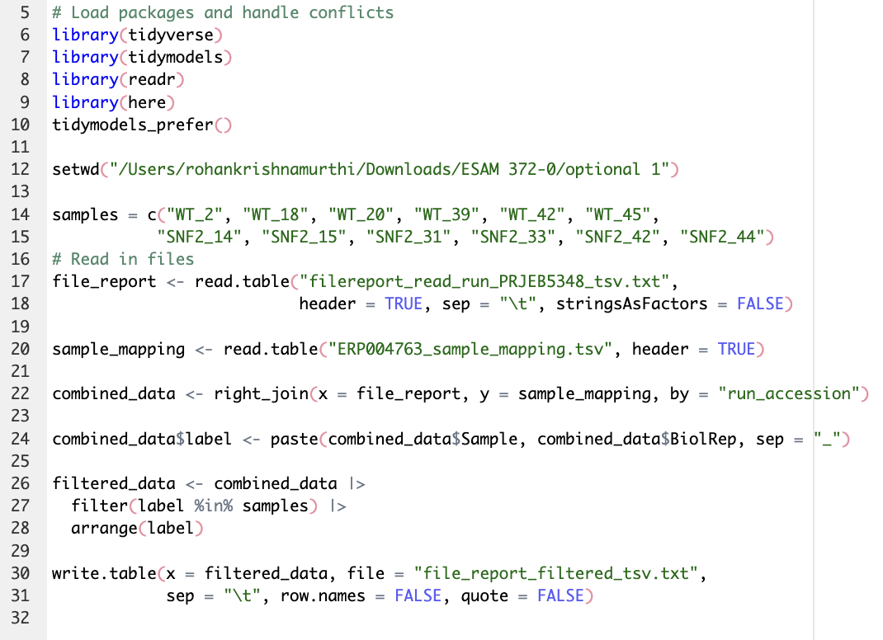
- Move filtered file to folder in Quest using Globus
- Write awk program: extract_col7.awk
  - BEGIN { FS=”\t” }
  - /vol1/ { print “wget “ $7 }
- Make a shell script:
  - awk -f extract_col7.awk file_report_filtered_tsv.txt > fastq_download_script.sh
- Invoke shell script
  - /bin/sh fastq_download_script.sh
- Start time: 9:15 pm
- End time: 12:28 am
- Elapsed time: 193 minutes

METHOD 2: fastq-dump from NCBI
- Prepare list of ERR files, transfer to Quest
- First command: module load sratoolkit
- Next commands: fastq-dump --gzip ERR458593
  - Repeat this command for all 84 files
- Start time: 1:13 am
- End time: 2:02 am

METHOD 3: fasterq-dump from NCBI, combined with gzip
- First command: module load sratoolkit
- Next commands:
  - fasterq-dump --outdir . ERR458593
  - gzip ERR458593.fastq
  - Repeat these command for all 84 files
- Start time: 2:24 am
- End time: 3:07 am

METHOD 4: ascp from the ENA
- First command: module load aspera
- Write new awk program using ascp: extract_col7_2.awk
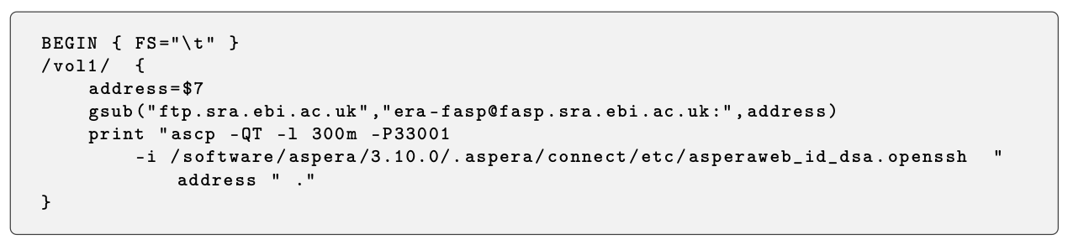
- Make a shell script:
  - Awk -f extract_col7.awk file_report_filtered_tsv.txt > fastq_download_script_2.sh
- Invoke shell script
  - /bin/sh fastq_download_script_2.sh
- Start time: 3:15 am
- End time:

METHOD 5: globus (command line) from the ENA skip

Method | Start Time | End Time | Time Elapsed
Wget | 9:15 pm | 12:28 am | 193 minutes
Fastq-dump | 1:13 am | 2:02 am | 49 minutes
Fasterq-dump, gzip | 2:24 am | 3:07 am | 43 minutes
ASCP from the ENA | 3:15 am | 3:31 am | 16 minutes

